**These are the factors that could influence residential home prices across the United States over the next decade:**

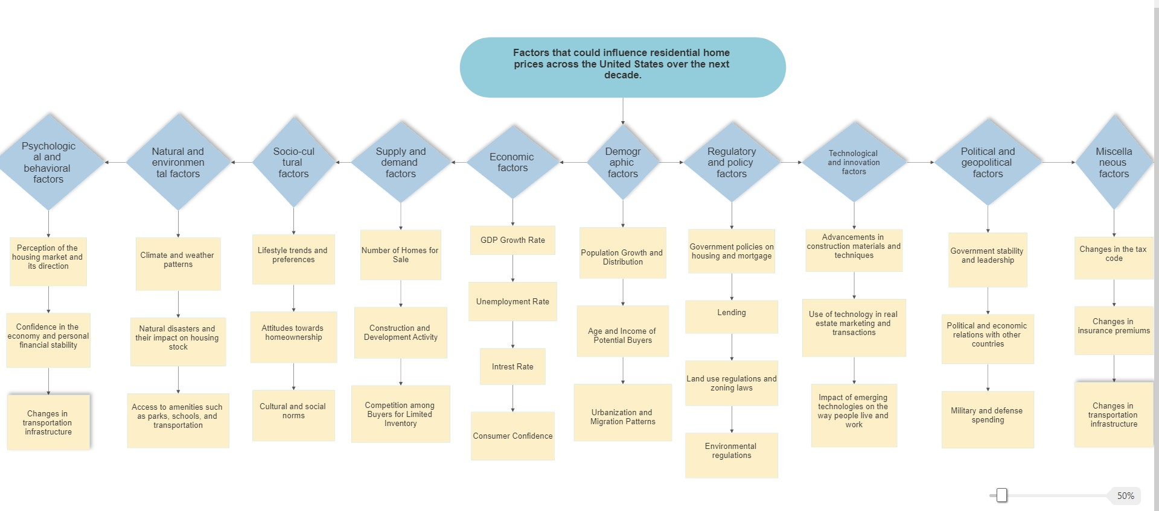

**Economic factors** can significantly affect the housing market and house prices. Here is how each of these factors can influence the market:

1.GDP growth rate: A strong economy, as indicated by a high GDP growth rate, can lead to an increase in demand for housing, which can drive up prices. On the other hand, a weak economy with a low GDP growth rate can lead to a decrease in demand and lower house prices.

2.Unemployment rate: A low unemployment rate usually indicates a strong economy, which can lead to higher demand for housing and higher house prices. On the other hand, a high unemployment rate can lead to a decrease in demand and lower house prices.

3.Inflation rate: If the inflation rate is high, it can lead to higher costs for builders and sellers, which may be passed on to buyers in the form of higher house prices. On the other hand, if the inflation rate is low, it may lead to lower house prices.

4.Interest rates: Interest rates play a significant role in the housing market. When interest rates are low, it can make borrowing cheaper, leading to an increase in demand for housing and higher house prices. On the other hand, high interest rates can make borrowing more expensive, leading to a decrease in demand and lower house prices.

**Demographic factors** can also impact the housing market and house prices. Here is how each of these factors can influence the market:

1.Population growth and distribution: An increase in population can lead to an increase in demand for housing, which can drive up prices. Similarly, if the population is concentrated in certain areas, it can lead to higher demand for housing in those areas and higher house prices.

2.Age and income of potential buyers: The age and income of potential buyers can also affect the housing market. For example, if there is a large number of young, high-income individuals looking to buy homes, it can lead to an increase in demand and higher house prices. On the other hand, if the majority of potential buyers are older or have lower incomes, it may lead to a decrease in demand and lower house prices.

3.Urbanization and migration patterns: Urbanization, or the process of people moving from rural to urban areas, can lead to an increase in demand for housing in urban areas and higher house prices. Similarly, if there is a trend of migration to certain areas, it can lead to higher demand for housing in those areas and higher house prices. On the other hand, if there is a trend of people moving away from certain areas, it can lead to a decrease in demand and lower house prices.

**Supply and demand factors** can significantly impact the housing market and house prices. Here is how each of these factors can influence the market:

1.Number of homes for sale: If there is a large number of homes for sale and a limited number of buyers, it can lead to a decrease in demand and lower house prices. On the other hand, if there is a limited number of homes for sale and a large number of buyers, it can lead to an increase in demand and higher house prices.

2.Construction and development activity: The level of construction and development activity can also affect the housing market. If there is a lot of new construction and development, it can lead to an increase in the supply of homes, which can drive down prices. On the other hand, if there is limited construction and development, it can lead to a decrease in the supply of homes and higher prices.

3.Competition among buyers for limited inventory: When there is competition among buyers for a limited number of homes, it can drive up prices due to the increased demand. On the other hand, if there is less competition among buyers, it may lead to lower prices.

**Regulatory and policy factors** can also impact the housing market and house prices. Here is how each of these factors can influence the market:

1.Government policies on housing and mortgage lending: Government policies on housing and mortgage lending can affect the availability and cost of financing for home buyers. For example, if the government imposes stricter lending standards, it may make it more difficult for some buyers to obtain financing, leading to a decrease in demand and lower house prices. On the other hand, if the government relaxes lending standards, it may make it easier for buyers to obtain financing, leading to an increase in demand and higher house prices.

2.3Land use regulations and zoning laws: Land use regulations and zoning laws can also affect the housing market. For example, if there are strict land use regulations or zoning laws that limit the development of new homes, it can lead to a decrease in the supply of homes and higher prices. On the other hand, if there are more lenient land use regulations and zoning laws that allow for more development, it can lead to an increase in the supply of homes and lower prices.

.Environmental regulations: Environmental regulations can also impact the housing market. For example, if there are strict environmental regulations that make it more costly to build homes, it can lead to higher construction costs and higher house prices. On the other hand, if there are less stringent environmental regulations, it may lead to lower construction costs and lower house prices.

**Socio-cultural factors** can also impact the housing market and house prices. Here is how each of these factors can influence the market:

1.Lifestyle trends and preferences: Lifestyle trends and preferences can affect the housing market by influencing the type of homes that people are looking for. For example, if there is a trend towards smaller, more sustainable homes, it may lead to a decrease in demand for larger, traditional homes and lower prices for those homes. On the other hand, if there is a trend towards larger, more luxurious homes, it may lead to an increase in demand for those homes and higher prices.

2.Attitudes towards homeownership: Attitudes towards homeownership can also impact the housing market. If there is a positive attitude towards homeownership, it may lead to an increase in demand and higher house prices. On the other hand, if there is a negative attitude towards homeownership, it may lead to a decrease in demand and lower house prices.

3.Cultural and social norms: Cultural and social norms can also affect the housing market. For example, in some cultures, it is traditional for multiple generations to live together in the same home. This may lead to a higher demand for larger homes with multiple bedrooms. In other cultures, it may be more common for people to live in smaller homes or apartments. This may lead to a higher demand for smaller homes and apartments and lower demand for larger homes.

**Technological and innovation factors** can also impact the housing market and house prices. Here is how each of these factors can influence the market:

1.Advancements in construction materials and techniques: Advancements in construction materials and techniques can affect the cost and efficiency of building homes. For example, if new materials or techniques are developed that make it cheaper or faster to build homes, it may lead to an increase in the supply of homes and lower house prices. On the other hand, if construction materials and techniques become more expensive or slower to use, it may lead to a decrease in the supply of homes and higher prices.

2.Use of technology in real estate marketing and transactions: The use of technology in real estate marketing and transactions can also impact the housing market. For example, if technology makes it easier for buyers to find and view homes online, it may increase demand and lead to higher house prices. On the other hand, if technology makes it easier for sellers to list and market their homes, it may increase the supply of homes and lead to lower prices.

3.Impact of emerging technologies on the way people live and work: Emerging technologies can also affect the housing market by changing the way people live and work. For example, if remote work becomes more common, it may lead to a decrease in demand for homes in urban areas and a shift towards demand for homes in more rural or suburban areas. On the other hand, if there is an increase in the use of electric or autonomous vehicles, it may lead to a shift in demand for homes with larger garages or closer to charging stations.

**Natural and environmental factors** can also impact the housing market and house prices. Here is how each of these factors can influence the market:

1.Climate and weather patterns: Climate and weather patterns can affect the housing market by influencing the demand for homes in certain areas. For example, if an area has a warm climate and good weather year-round, it may lead to an increase in demand for homes in that area and higher house prices. On the other hand, if an area has a harsh climate or frequent natural disasters, it may lead to a decrease in demand and lower house prices.

2.Natural disasters and their impact on housing stock: Natural disasters can also impact the housing market by damaging the housing stock in an area. If there is a natural disaster that destroys or damages many homes in an area, it can lead to a decrease in the supply of homes and higher prices. On the other hand, if an area is less prone to natural disasters, it may lead to a stable supply of homes and more stable prices.

3.Access to amenities such as parks, schools, and transportation: Access to amenities such as parks, schools, and transportation can also affect the housing market. If an area has good access to amenities, it may lead to an increase in demand for homes in that area and higher house prices. On the other hand, if an area has limited access to amenities, it may lead to a decrease in demand and lower house prices.

**Political and geopolitical factors** can also impact the housing market and house prices. Here is how each of these factors can influence the market:

1.Government stability and leadership: Government stability and leadership can affect the housing market by influencing consumer confidence and the overall health of the economy. If the government is stable and effective, it may lead to an increase in demand for housing and higher house prices. On the other hand, if the government is unstable or ineffective, it may lead to a decrease in demand and lower house prices.

2.Political and economic relations with other countries: Political and economic relations with other countries can also impact the housing market. For example, if a country has strong economic ties with other countries and a positive trade balance, it may lead to an increase in demand for housing and higher house prices. On the other hand, if a country has weak economic ties with other countries or a negative trade balance, it may lead to a decrease in demand and lower house prices.

3.Military and defense spending: Military and defense spending can also affect the housing market. If a country has a high level of military and defense spending, it may lead to an increase in demand for housing near military bases or in areas with a strong defense industry, and higher house prices in those areas. On the other hand, if a country has a low level of military and defense spending, it may lead to a decrease in demand for housing in those areas and lower house prices.

**Psychological and behavioral factors** can also impact the housing market and house prices. Here is how each of these factors can influence the market:

1.Perception of the housing market and its direction: Perception of the housing market and its direction can affect the willingness of people to buy or sell homes. If people perceive the housing market as strong and trending upwards, they may be more likely to buy homes, leading to an increase in demand and higher house prices. On the other hand, if people perceive the market as weak or declining, they may be less likely to buy homes, leading to a decrease in demand and lower house prices.

2.Confidence in the economy and personal financial stability: Confidence in the economy and personal financial stability can also impact the housing market. If people feel confident about their financial future and the economy, they may be more likely to buy homes, leading to an increase in demand and higher house prices. On the other hand, if people are not confident about their financial future or the economy, they may be less likely to make such a significant purchase, leading to a decrease in demand and lower house prices.

3.Risk tolerance and investment preferences: Risk tolerance and investment preferences can also affect the housing market. If people are more risk-tolerant and prefer to invest in real estate, they may be more likely to buy homes, leading to an increase in demand and higher house prices. On the other hand, if people are less risk-tolerant and prefer other types of investments, they may be less likely to buy homes, leading to a decrease in demand and lower house prices.

**Miscellaneous factors** can also impact the housing market and house prices. Here is how each of these factors can influence the market:

Changes in the tax code: Changes in the tax code can affect the housing market by influencing the cost of buying and owning a home. For example, if the tax code is changed to provide incentives for homeownership, it may lead to an increase in demand for homes and higher house prices. On the other hand, if the tax code is changed to make homeownership less attractive, it may lead to a decrease in demand and lower house prices.

Changes in insurance premiums: Changes in insurance premiums can also impact the housing market. If insurance premiums for homeowners increase significantly, it may make owning a home more expensive and lead to a decrease in demand and lower house prices. On the other hand, if insurance premiums for homeowners decrease, it may make owning a home more affordable and lead to an increase in demand and higher house prices.

Changes in transportation infrastructure: Changes in transportation infrastructure can also affect the housing market. If there are improvements to transportation infrastructure, such as the construction of new roads or public transportation systems, it may make certain areas more accessible and lead to an increase in demand for homes in those areas and higher house prices. On the other hand, if there are declines in transportation infrastructure, it may make certain areas less accessible and lead to a decrease in demand and lower house prices.